**DEVELOPMENT OF ANDROID APPLICATION TO HELP CANCER PATIENTS**

Project Report submitted in

Partial fulfillment of requirement for the degree

of

BACHELOR OF TECHNOLOGY

in

COMPUTER SCIENCE & ENGINEERING

Ms.

AKSHAT MAURYA (2004310100013) (Project Coordinator)



**DEPARTMENT OF COMPUTER SCIENCE & ENGINEERING**

**B.N. COLLEGE OF ENGINNERING & TECHNOLOGY**

**LUCKNOW, (UTTAR PRADESH)**

**SESSION: 2022-23**

**DECLARATION**

We hereby declare that the term project work entitled **‘Devlopment of a Android application to monitor cancer patients’** has been carried out with **Ms. Tripti Sahu**. This work is an original or emulated work, which was carried out for learning as a term project for 3rd Semester CSE(Cmputer Science & Engineering).

**Name’s :**

AKSHAT MAURYA (2004310100013)

Place : Lucknow

Date : December 2022



**Declaration of originality of work and report by the students**

We have not committed plagiarism in any of the form described in the ‘Plagiarism policy’. We have documented all methods, data, and processes truthfully and we have not manipulated any data. We have mentioned all the persons who are significant facilitators of the work. The work has been screened electronically for plagiarism.References, help and material obtained from other sources have been duly acknowledged.

Name : Akshat Maurya Roll no : 2004310100013

Place : Lucknow Date : December 2022



**CERTIFICATE**

This is to certify that this thesis report entitled **‘Devlopment of a Android application to Monitor Cancer Patients’** is a bonafide project work carried out and completed by **,Akshat Maurya (2004310100013)** This is an original piece /emulated work, done as per the regulations of the **B.N. COLLEGE OF ENGINNERING & TECHNOLOGY** for the purpose of project learning.

**ACKNOWLEDGEMENT**

We would like to express my special thanks of gratitude to our Guide Assosiate Prof. **Ms. Tripti Sahu**  who gave us this opportunity to do this wonderful project on the topic (Cancer Patient Help App for Android), which also helped us in doing a lots of Research and we came to know about so many new things which helped us in enhancing our language.

Secondly i would also like to thank my parents and friends who helped me a lot in finalizing this project within the limited time frame.

**ABSTRACT**

In this project we will be dealing with android application for Cancer Patients for monitoring their symptoms and health issues using Python based Django framework& Android .

This application is made with the intension that it will help doctors , staff and admin department of the hospital so that they can monitor the patient’s health issues.

With the help of this application doctors need not always ask for the patient’s symptoms and patients need not make record of all the detailed symptoms. With this intension we are developing this application for patients.

There are various side effects associated with cancer treatments. Patients do not always get the opportunity to convey their symptoms immediately to the doctors, to overcome such scenarios patient only need to access this application at home for monitoring and communicating about their symptoms and associated remedies with doctor. And they can continue their remedies themselves.

Our application enables the monitoring of patient reported symptoms in real-time and after sometimes they can give review about their health, how the remedies are working.

After taking feedback from patient doctor will monitor their health and suggest what to do next.

CONTENTS

Chapter 1 INTRODUCTION 11

1.1 Introduction 11

Chapter 2 Literature review 13

Chapter 3 Software&HARDWARE RequirementS 14

Chapter 4 objective of the project 15

Chapter 5 Implementation 16

5.2 For Android Application 17

Chapter 6 BLOCK dIAGRAM 18

Chapter 7 fINAL DATA FLOW dIAGRAM 19

7.2 For Android Application 20

Chapter 8 Software Design 22

8.1 Database Design 22

8.2 For Android Application 24

Chapter 9 SCREENSHOTS 25

Chapter 10 Software installations steps 34

11.2 Android Installation Steps 34

Chapter 11 Future scope 37

Chapter 12 : CONCLUSION 38

Chapter 13 Bibliography 39

**LIST OF FIGURES**

figure 1 Block Diagram 18

Figure 2 Data Flow Diagram 19

Figure 3 Data Flow Diagram 20

Figure 4 Data Flow Diagram 21

Figure 5 Login& Registration 25

Figure 6 Login Language Change 26

Figure 7 Login In Different Language & Dashboard 27

Figure 8 Side Effect & Remedies 28

Figure 9 Feedback 29

Figure 10 Contact 29

Figure 11 Home Page 30

Figure 12 Login 30

Figure 13 Admin Section 31

Figure 14 Doctor Panel 31

Figure 15 Staff Registration 31

Figure 16 Medical Detail Form 32

Figure 17 Patient Demography 32

Figure 18 Side Effect 33

Figure 19 Chemo Cycle 33

Figure 20 Remedies 34

Figure 21 View Feedback 34

Figure 22 Sub Remedies 34

Figure 23 Android Studio Installation 36

Figure 24 Python Installation 36

Figure 25 Django Installation 37

Figure 26 Postgres Installation 37

**List of Tables**

Table 1:Login Master 22

Table 2: Patient Demograpghy Detail 22

Table 3:Side Effect 22

Table 4:Remedies 22

Table 5:Sub Remedies 23

Table 6:Feedback 23

Table 7:Enquiry 23

Table 8:Chemo Cycle 23

Table 9: Staff Master 23

Table 10:Department 23

Table 11 Chemo Detail 23

Table 12: Login for Android 24

Table 13:Registration For Android 24

Table 14:feedback Table for android 24

# INTRODUCTION

## Introduction

Cancer is the name given to a collection of related diseases. In all types of cancer, some of the body’s cells begin to divide without stopping and spread into surrounding tissues.

Cancer can start almost anywhere in the human body, which is made up of trillions of cells. Normally, human cells grow and divide to form new cells as the body needs them. When cells grow old or become damaged, they die, and new cells take their place.

When cancer develops, however, this orderly process breaks down. As cells become more and more abnormal, old or damaged cells survive when they should die, and new cells form when they are not needed. These extra cells can divide without stopping and may form growths called tumors

Patients with cancer, pain is one of the most frequent and fearsome  
symptoms. In the ambulatory setting, half of the patients had been reported that they were in pain and approximately 20% that they had moderate to severe pain.

Treatment protocols vary according to the type and stage of the cancer. Most treatment protocols are designed to fit the individual patient's disease. However, most treatments include surgery, chemotherapy and therapy. Most treatment protocols are designed to fit the individual patient's disease.

Patients have various concerns and misconceptions about pain and analgesics, and the communication about their pain to professionals is poor. This is especially important in the ambulatory setting. Pain assessment takes place at the outpatient clinic and relies on retrospective patient recall. As a result, timely adjustment of pain management is delayed. When patients are at home, they have to take a more active role in monitoring and communicating about their pain.

Many medical applications have been developed and widely used by health professionals and patients. In the ambulatory setting, half of the patients had been reported that they were having many symptoms.

.

# Literature review

1. Supportive care needs of cancer patients **Ayana Smith, B.S.N., R.N., Yolanda M. Hyde, Ph.D., R.N., B.C., O.C.N.**,

* Previously conducted a search of online databases of peer-reviewed studies published in the English language between 2009 and 2014.
* This paper reviews research studies . that explored the supportive care needs of cancer patients through focus groups, surveys, and interviews.

1. Galvan and colleagues (2009) studied the emotional, informational, ﬁnancial support needs of immigrant women.

* These studies reveal cancer patients’ needs during all phases of treatment.

1. The purpose of this study was to investigate whether it is most important to identify patient needs for support.
2. Caring for Caregivers and Patients: Research and Clinical Priorities for Informal Cancer Care giving **Erin E. Kent, Julia H. Rowland,Laurel Northouse, Kristin Litzelman, Wen-Ying Sylvia Chou Nonniekaye**
3. The impact of coping strategies of cancer caregivers on psychophysiological outcomes : an integrative review -**Ricardo João Teixeira, Allison J Applebaum, Sangeeta Bhatia, and Tânia Brandão**

Software&HARDWARE RequirementS

|  |  |  |
| --- | --- | --- |
| Serial No. |  | Android Application |
| 1. |  | Android Studio 2 and above |
| 2. |  | SQL Lite Database |
| 3. |  | Android version 4 and above |
| 4. |  | 1GB RAM |
| 5. |  | 150 MB ROM |
| 6. |  |  |
| 7 |  |  |

# objective of the project

This application is made with the intension of overcoming barriers regarding communication related to both professional and patient .

The intension of developing this project is to provide the cancer patients a place where they can keep record of there symptoms, maintain the record of their Chemo cycles if given, send a feedback to doctors so that they can know which remedy worked best for their patient.

With the help of this application patient can keep track easily rather that just remembering and recalling.

Our application enables the monitoring of patient reported symptoms in real-time. And after sometimes they can give review about their health, how the remedies are working or doctor will contact to them according to their health severity.

Implementation

## For Android Application

* Login for Patients
* Registration for patients
* View Side Effects
* View remedies & Sub remedies
* Get Contact Information

# Screenshot (6).pngBLOCK dIAGRAM

Figure BLOCK DIAGRAM

fINAL DATA FLOW dIAGRAM

## 7.1 For Android Application

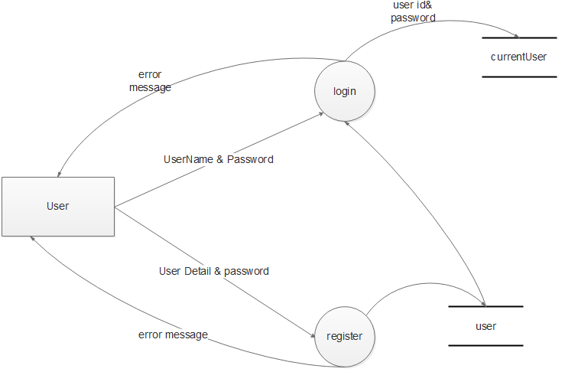

Figure DATA FLOW DIAGRAM

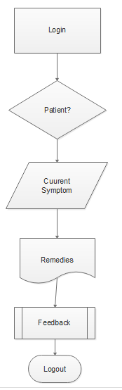

# Software Design

Software design is the process of envisioning and defining software solutions to one or more sets of problems. One of the main components of software design is the software requirements analysis which helps the programmer in software coding and implementation. For assessing user requirements, an SRS (Software Requirement Specification) for coding and implementation, there is a need of more specific and detailed requirements in software terms.

## 8.1 Database Design

Table 1: Login Master

|  |  |  |
| --- | --- | --- |
| Login Master | | |
| Role | Staff ID/File Number | Password |

Table 2: Patient Demography Detail

|  |  |  |  |  |  |  |
| --- | --- | --- | --- | --- | --- | --- |
| Patient Demography Details | | | | | | |
| File Number | Name | Date Of Birth | Gender | Aadhar | Contact Number | Address |

Table3: Patient Medical Detail

|  |  |  |  |  |  |  |
| --- | --- | --- | --- | --- | --- | --- |
| Patient Medical Details | | | | | | |
| File Number | Department ID | Visit Date | Staff ID | Next Visit Date | Remarks | Diagnostic Suggestions |

Table 3: Side Effect

|  |  |
| --- | --- |
| Side Effect | |
| Side Effect ID | Side Effect Name |

Table 4: Remedies

|  |  |  |
| --- | --- | --- |
| Remedies | | |
| Remedy ID | Side Effect ID | Remedy |

Table 5:Sub Remedies

|  |  |  |
| --- | --- | --- |
| Sub Remedies | | |
| Remedy ID | Sub Remedy ID | Sub Remedy |

## 

Table 6:Feedback

|  |  |  |  |  |  |  |
| --- | --- | --- | --- | --- | --- | --- |
| Feedback from patients | | | | | | |
| File Number | Serial Number | Side Effect ID | Side Effect name | Side Effect Date | Side Effect Time | Recovery Input |

Table 7:Enquiry

|  |  |  |  |  |  |
| --- | --- | --- | --- | --- | --- |
| Enquiry from patient | | | | | |
| Name | Subject | Query | Contact | Email | ID |

Table 8:Chemo Cycle

|  |  |  |  |
| --- | --- | --- | --- |
| Chemo Cycle | | | |
| Name | Doctor | Date | Time |

Table 9: Staff Master

|  |  |  |  |  |  |  |  |
| --- | --- | --- | --- | --- | --- | --- | --- |
| Staff Master | | | | | | | |
| Staff ID | Name | Date of Birth | Email Address | Contact Number | Department ID | Designation | Role |

Table 10:Department

|  |  |
| --- | --- |
| Department Master | |
| Department ID | Department Name |

Table Chemo Detail

|  |  |  |  |  |  |  |  |  |  |  |  |  |
| --- | --- | --- | --- | --- | --- | --- | --- | --- | --- | --- | --- | --- |
| name | blood | protocol | trial | dignosis | frquency | drugs | conta | date | Treatment number | Special blood | V Acess | File Number |
|  |  |  |  |  |  |  |  |  |  |  |  |  |

## 8.2 For Android Application

Table 12: Login for Android

|  |  |
| --- | --- |
| Login | |
| User Name | Password |

|  |  |  |  |  |  |
| --- | --- | --- | --- | --- | --- |
| Registration Details | | | | | |
| User Name | First Name | Last Name | Email | Password | Contact Number |

Table 13:Registration For Android

Table 14:feedback Table for android

|  |  |  |  |  |
| --- | --- | --- | --- | --- |
| Feedback form for patients | | | | |
| Feedback | Severity | List of Symptoms | Date From | Date To |

# SCREENSHOTS

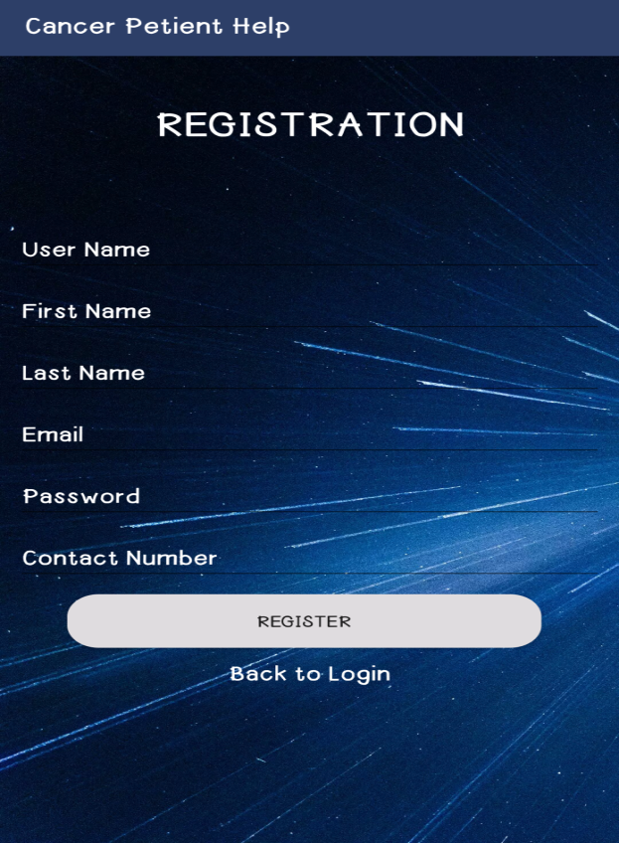**9.1 Android Application ScreenShots**

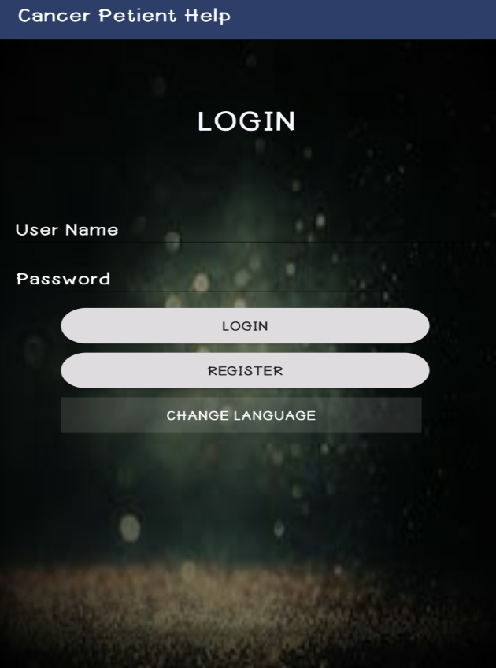

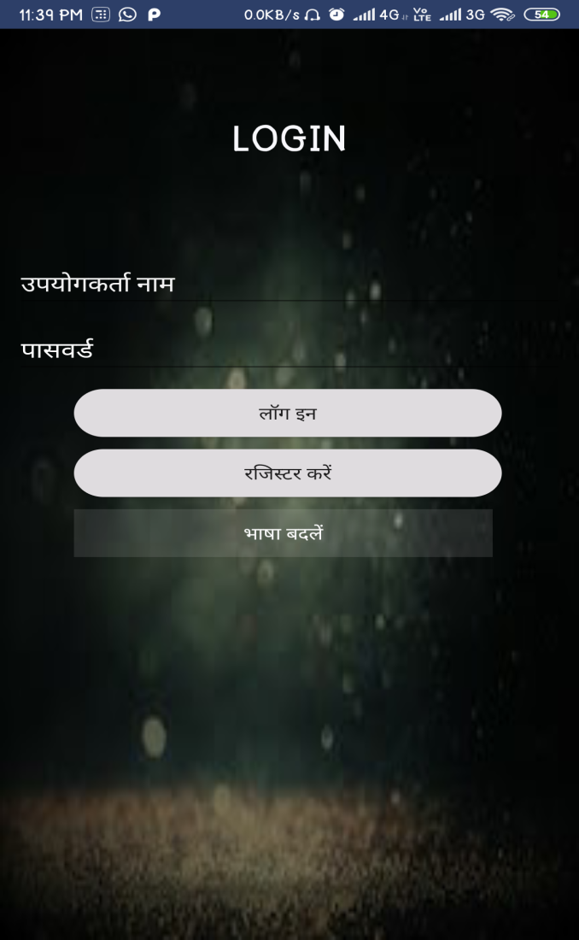

Figure Login& Registration

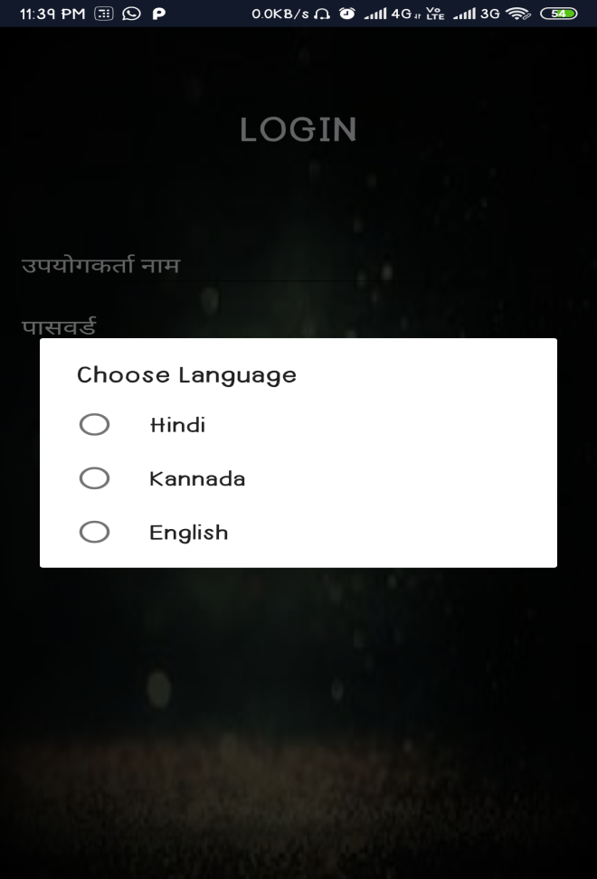

Figure Login Language Change

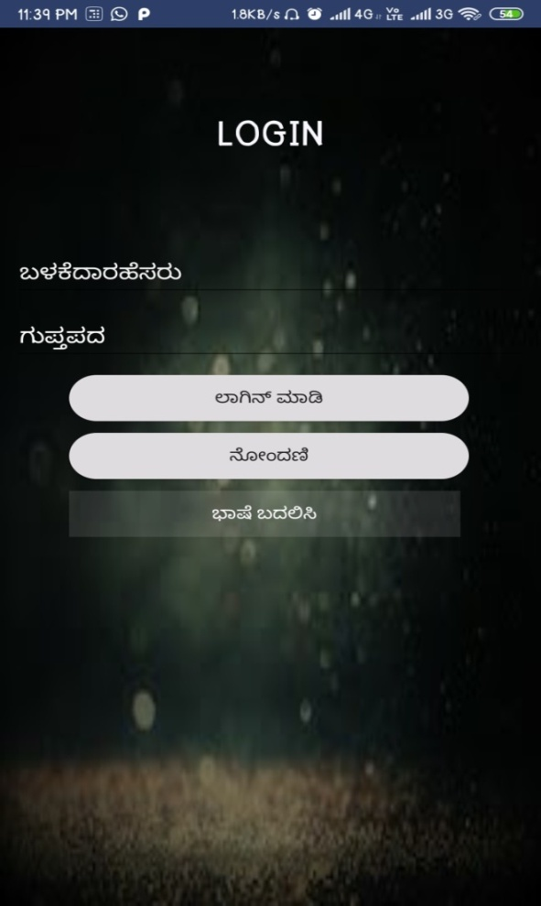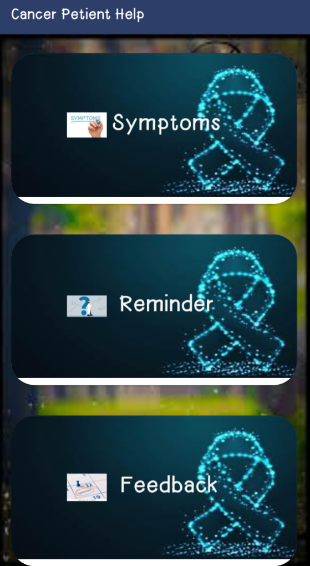

Figure Login in different language & Dashboard

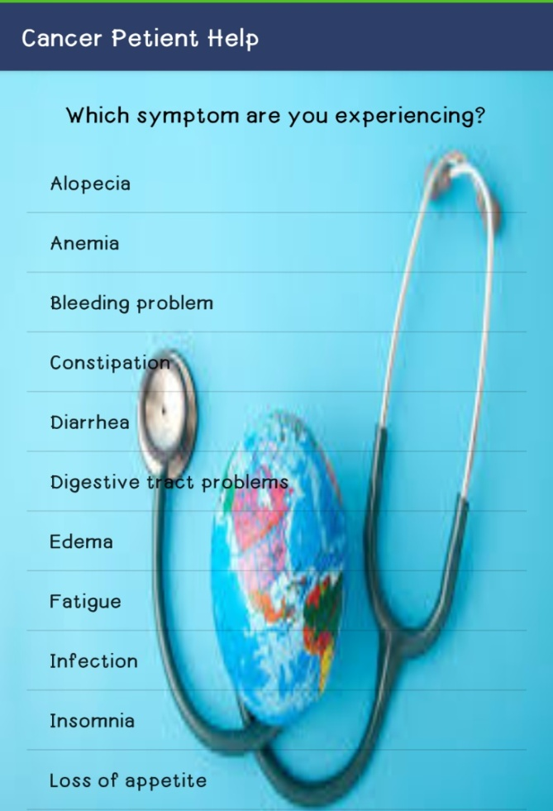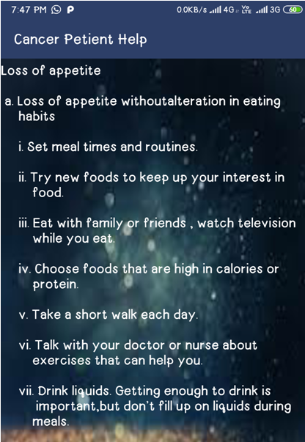

Figure Side Effect & Remedies

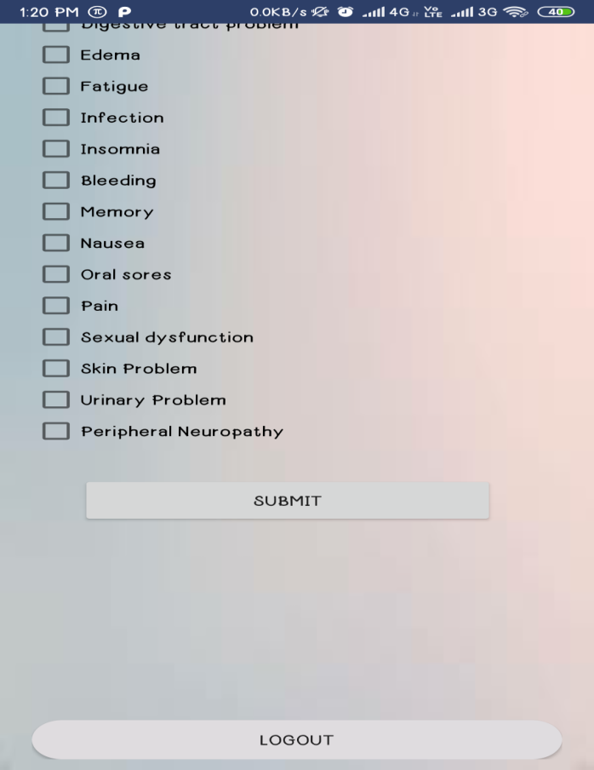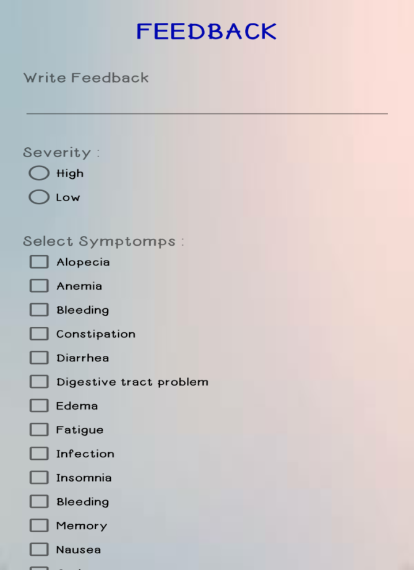



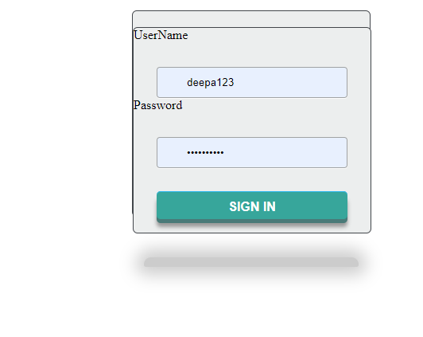

Figure Login

Figure Contact

# Software installations steps

## 11.2 Android Installation Steps

!. Install Android studio IDE

2. Install Android studio SDK

n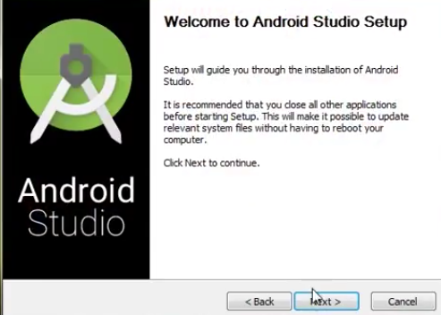

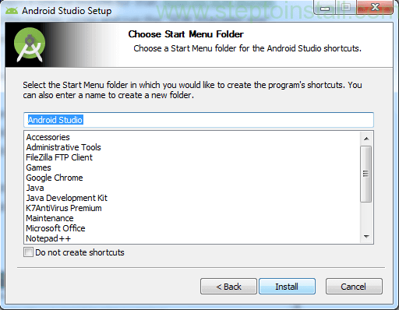

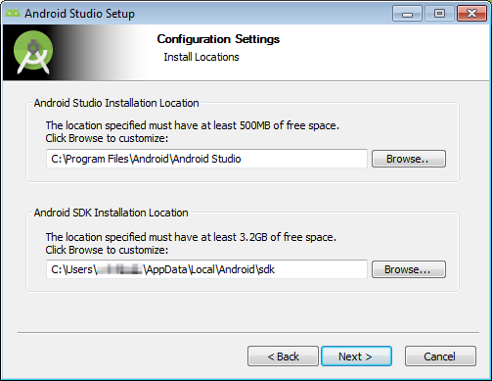

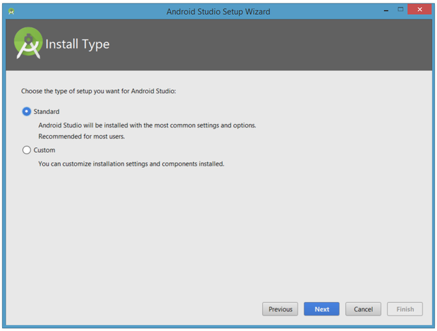

Figure Android Studio Installation

Future scope

Being a software , there is always a possibility and chance to keep on working and updating hence providing better functionality.

In the near future we can try to implement

* Synchronization between the android and web application
* Implementation of reminders in android application
* Plotting of graph to better understand the severity of the side effects

# : CONCLUSION

With the help of this project, a user can get to know about their symptoms and can get the prescribed set of remedies which can help them in overcoming the pain.

It is also helpful for doctors as they can keep the track of the symptoms of their patient which could also be helpful for them in prescribing better medications for them and with the feedbacks given by the patients, doctor can also get to know which remedies are working on patient and which are not.

Apart from this, it would also be helpful for organization as they can keep track of patient medical record.

# Bibliography

1. <https://docs.djangoproject.com/en/1.8/intro/tutorial01/>
2. <https://www.djangoproject.com/start/>
3. <http://www.postgresqltutorial.com/>
4. <https://www.postgresql.org/docs/8.0/tutorial.html>
5. <https://developer.android.com/training/basics/firstapp/>
6. <https://stackoverflow.com/questions/34797307/onclicklistener-in-a-checkbox-android-studio>
7. <https://stackoverflow.com/questions/9229516/using-listview-in-android>
8. <https://stackoverflow.com/questions/12015731/android-sqlite-example>
9. <https://stackoverflow.com/questions/36631419/display-data-from-a-database-in-a-html-page-using-django>
10. <https://djangobook.com/mdj2-models/>
11. <https://www.cancer.gov/about-cancer/treatment/side-effects>
12. <https://www.cancer.net/survivorship/long-term-side-effects-cancer-treatment>
13. <https://www.tutorialspoint.com/django/index.htm>

**PROEJCT TEAM MEMBER DETAILS**

|  |  |
| --- | --- |
| **NAME** | **Akshat Maurya** |
| **BRANCH** | **CSE** |
| **REGISTRATION NUMBER** | **2004310100013** |
| **MOBILE NUMBER** | **6307815581** |
| **EMAIL ID** | **Akshatmaurya132@gmail.com** |